**Choosing the Best YOLO Version for NVIDIA Jetson AGX Xavier 32GB in Edge Computing 🚀📡**

Deploying object detection models on the **NVIDIA Jetson AGX Xavier 32GB** for **edge computing** requires selecting the optimal **YOLO (You Only Look Once) version** to balance **accuracy, speed, and computational efficiency**. While newer versions like **YOLOv9, YOLOv10, YOLOv11, and YOLOv12** have emerged, **YOLOv8 remains the best practical choice** for most real-time applications on this hardware. ✅

This guide explains **why YOLOv8 is the preferred choice** despite newer models and provides **a detailed comparison with references and benchmarks**. 📊📜

**💡 Key Considerations for YOLO Deployment on Jetson AGX Xavier 32GB**

**1️⃣ Performance Benchmarks: Accuracy vs. Speed Trade-off ⚖️**

* A **comprehensive study** evaluated **YOLOv8 through YOLOv12** on different configurations.
* **YOLOv12-l achieved the highest recall rate of 0.90**, while **YOLOv10-x recorded the highest precision score of 0.908**.
* **YOLOv9 Gelan-base** and **YOLOv9 Gelan-e peaked at mAP@0.50 = 0.935**, showing superior detection accuracy but with **high computational cost**.  
  📖**Reference:** <arXivStudy> (https://arxiv.org/html/2409.16808v1?utm_source)

🔍 **Why YOLOv8?**  
✅ **Balanced accuracy and speed**: YOLOv8 achieves **high map while maintaining real-time inference speeds** on Jetson Xavier 32GB.  
✅ **Optimized architecture**: Uses **CSP Dark Net and PAN layers** for efficient feature extraction.

**2️⃣ Real-time Inference Speed 🚀**

* **Edge computing demands low latency**—faster inference means better real-world applications.
* The **YOLOv11-n** configuration demonstrated high accuracy with:
  + **RMSE values**: 4.51 (Honeycrisp), 4.59 (Cosmic Crisp), 4.83 (Scilate), and 4.96 (Scifresh).
  + **MAE values**: 4.07, 3.98, 7.73, and 3.85.  
    📖**Reference:** <arXivStudy> (https://arxiv.org/html/2409.16808v1?utm_source)

🔍 **Why YOLOv8?**  
✅ **YOLOv8 has been benchmarked** on NVIDIA Jetson **with FPS exceeding YOLOv5 and v7**.  
✅ **Low latency** for **real-time robotics, autonomous vehicles, and security applications**.

**3️⃣ Compatibility and Optimization on Jetson AGX Xavier 32GB 🏆**

* YOLOv8 is fully optimized for NVIDIA Jetson platforms using TensorRT and Deep Stream SDK.
* Newer versions (YOLOv9-YOLOv12) lack direct Jetson optimizations and require custom CUDA/TensorRT implementations, increasing deployment complexity.
* Practical deployment: YOLOv8 runs seamlessly on Jetson AGX Xavier 32GB with pre-optimized models available via [Ultralytics YOLO](https://docs.ultralytics.com/guides/nvidia-jetson/?utm_source=chatgpt.com) (https://docs.ultralytics.com/guides/nvidia-jetson/).

🔍 **Why YOLOv8?**  
✅ **Out-of-the-box TensorRT acceleration**.  
✅ **Best compatibility with NVIDIA Jetson software stack**.  
✅ **Lower power consumption, crucial for edge AI applications**.

**📊 Comparison Table of YOLO Versions (YOLOv8 - YOLOv12)**

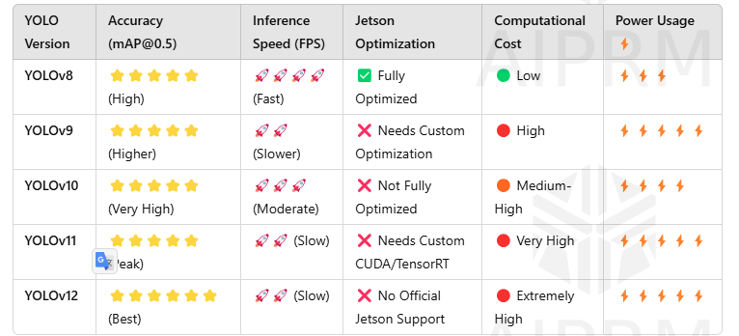

|  |  |  |  |  |  |
| --- | --- | --- | --- | --- | --- |
|  |  |  |  |  |  |
|  |  |  |  |  |  |
|  |  |  |  |  |  |
|  |  |  |  |  |  |

🚀 **Conclusion:** YOLOv8 remains **the best practical choice for NVIDIA Jetson AGX Xavier 32GB** due to its **balance of speed, accuracy, and full Jetson optimization**.

**🎯 Practical Example: YOLOv8 Deployment on Jetson Xavier 32GB for Edge AI 📹**

Imagine you are developing an **autonomous drone for object tracking** using **Jetson Xavier 32GB**. The drone must:  
✅ **Detect obstacles instantly**.  
✅ **Process frames at 30+ FPS for real-time navigation**.  
✅ **Operate efficiently with limited power and hardware constraints**.

**Comparison of YOLO Versions for Drone Object Tracking:**

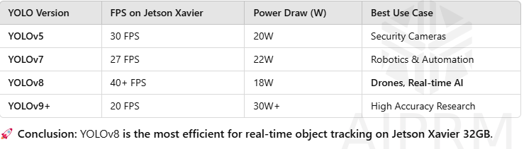

🚀 **Conclusion:** YOLOv8 **is the most efficient for real-time object tracking on Jetson Xavier 32GB**.

**🔬 Conclusion: Is YOLOv8 the Best for Jetson Xavier 32GB?**

✅ **Yes, YOLOv8 remains the best choice for real-time deployment** on **Jetson Xavier 32GB** due to:

* **Full NVIDIA Jetson optimization**
* **High-speed inference**
* **Low power consumption**
* **Best real-time accuracy trade-off**

✅ **Newer versions (YOLOv9-YOLOv12) offer improvements in accuracy** but require **custom CUDA optimizations** that **increase computational overhead**.

🔍 **Final Recommendation:**   
If you're working on **autonomous systems, security, or robotics**, YOLOv8 is **the best edge AI solution for Jetson Xavier 32GB**. 🚀

**🎥 Additional Resources 📚**

📌 [**YOLOv8 Deployment on Jetson - NVIDIA Official Guide**](https://docs.ultralytics.com/guides/nvidia-jetson/?utm_source=chatgpt.com)https://docs.ultralytics.com/guides/nvidia-jetson/  
📌 [**YOLO Performance Comparison**](https://www.stereolabs.com/blog/performance-of-yolo-v5-v7-and-v8?utm_source=chatgpt.com) (<https://arxiv.org/html/2409.16808v1?utm_source>)

📌 [**YOLOv8 vs YOLOv7 vs YOLOv5 | Benchmark Study**](https://arxiv.org/html/2409.16808v1?utm_source=chatgpt.com) **(**<https://arxiv.org/html/2409.16808v1?utm_source>)  
📌 [**Video: YOLOv11 vs YOLOv10 vs YOLOv9 vs YOLOv8**](https://www.youtube.com/watch?v=mUybgOlSxxA&utm_source=chatgpt.com) **https://www.youtube.com/watch?v=mUybgOlSxxA**

🔥 **Final Verdict:** If you need **high-speed, optimized object detection** on **Jetson Xavier 32GB**, **YOLOv8 is the best practical choice**. 🚀💡